**User Manual**

**On**

# Attendance Management

**Project Manager:**

**Dr. Kazi Masudul Alam**

**Associate Professor**

**Computer Science & Engineering Discipline**

**Khulna University, Bangladesh**

**Developed by:**

**Dabashis Kundu Shento (170209)**

**Mostaq Ahmed Polok (170232)**

**Attendance Module Page:  
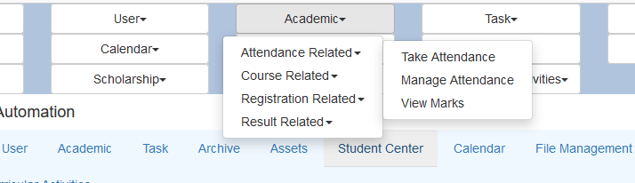**

Fig: Attendance Module Page  
  
There are three sub-sections:

* Take Attendance
* Manage Attendance
* View Marks

**1. Take Attendance:**   
  
Teacher can find courses by selecting year. Then he/she can select course and take attendance from this sub-sections.

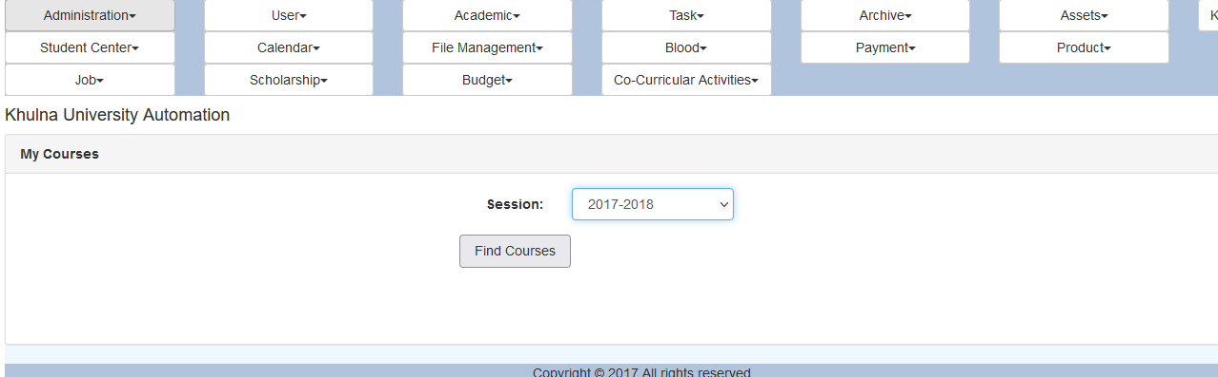

Fig: Session Year Page

**i.** Find course will give courses respected to that teacher.

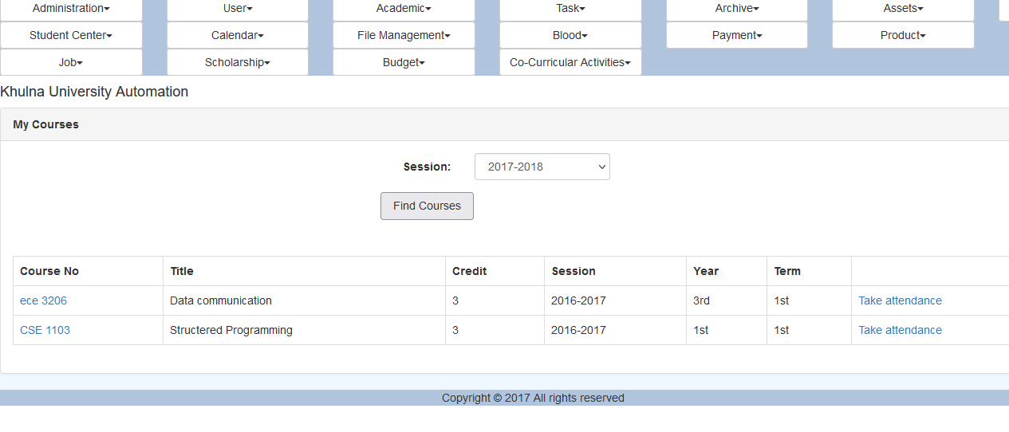

Fig: My course page

**ii.** In my course page, there is a column for taking attendance.

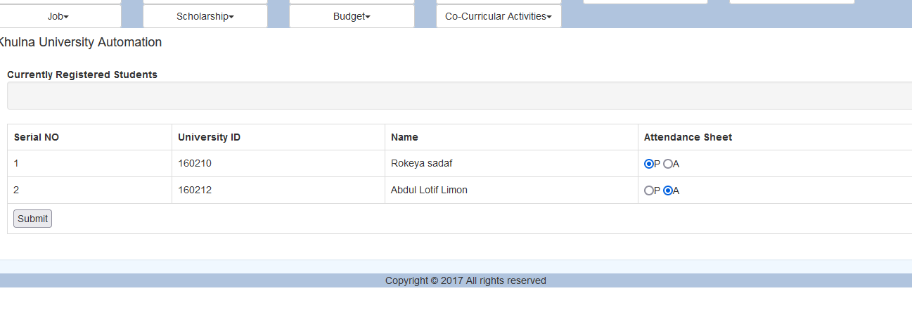

Fig: Student List Page

**ii.** Student list of a course. From this page teacher can give attendance to a student enrolled to that course by selecting either present or absent.

**2. Mange Attendance:**  
There might be a case where teacher wants to re-assign students’ attendance. In this section, teacher can open students’ attendance sheet by selecting course.

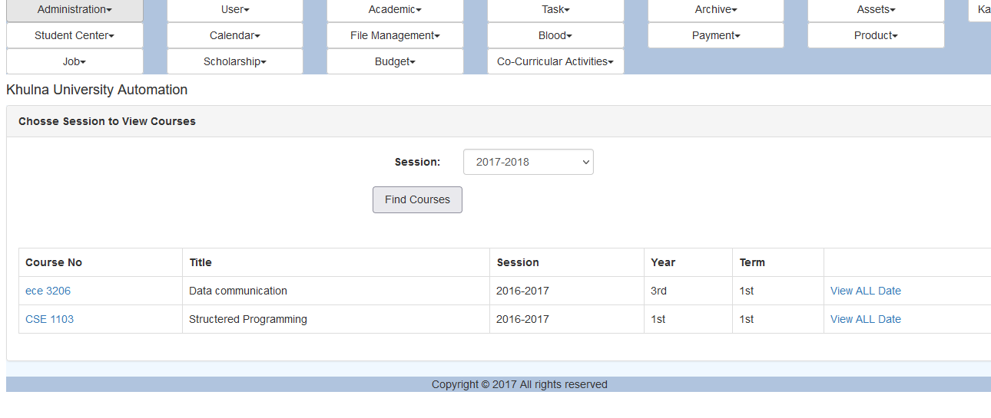

Fig: View Date page

**i.** View date page will give all the dates where attendance has been already taken.

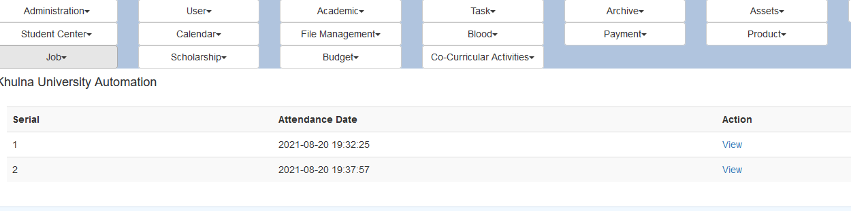

Fig: All Date Page

**ii.** All dates will be displayed in here.

Fig: Re-assign Page

**iii.** Teacher can re-assign student’s attendance status.

**3. View Marks:**

From this sub-section, teacher can view attendance mark of a student based on our attendance marking system. This can be done by selecting course name and session year.

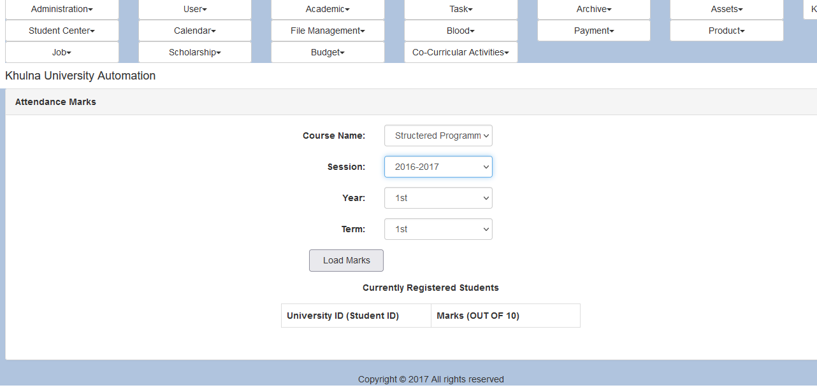

Fig: View Marks Page

**i.** Marks will be displayed in this page. This marks is calculated out of 10.

**Thank you.**